OOP Exercises
Exercise 1: Define an Empty Vehicle Class
Problem Statement: Write a Python program to create a class named Vehicle that has no variables or methods defined inside it.
Purpose: This exercise introduces the most basic form of a Python class definition. It teaches you the required syntax for declaring a class and the use of the pass keyword as a placeholder, which is essential when you want to define an empty class or function body without causing a syntax error.
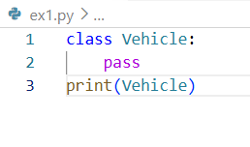
Exercise 2: Vehicle Class with Instance Attributes
Problem Statement: Write a Python program to create a Vehicle class with two instance attributes: max_speed and mileage. Create an object of the class and print both attributes.
Purpose: Learn to define instance attributes using the __init__ constructor method. Instance attributes are unique to each object, meaning different Vehicle objects can hold different values for speed and mileage. This is a foundational concept in object-oriented programming.
Given Input: vehicle1 = Vehicle("Tesla Model S", 250, 18)
Expected Output: Vehicle Name: Tesla Model S, Speed: 250, Mileage: 18
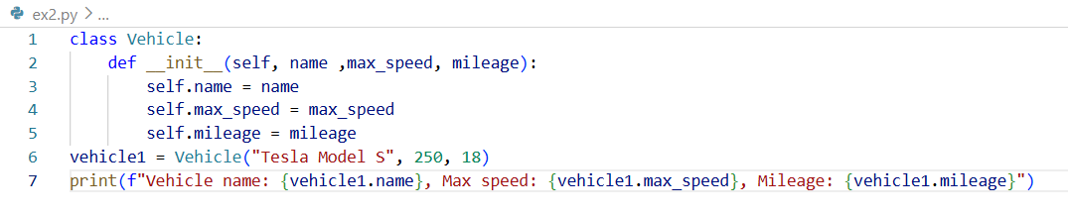
Exercise 3: Rectangle Class with Area & Perimeter
Problem Statement: Write a Python program to create a Rectangle class with length and width as instance attributes, and two methods: area() that returns the area and perimeter() that returns the perimeter.
Purpose: Learn how to add instance methods to a class. Methods allow objects to perform operations using their own data, which is a key principle of encapsulation in OOP. Calculating geometric properties is a clean, practical context for understanding how self connects methods to instance data.
Given Input: rect = Rectangle(10, 4)
Expected Output: Area = 40 and Perimeter = 28
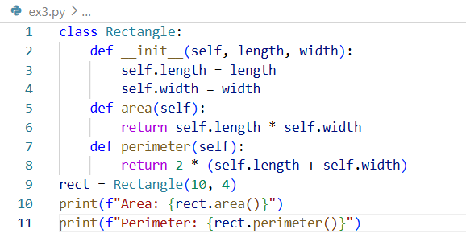
Exercise 4: Student Class with Average Grade
Problem Statement: Write a Python program to create a Student class that stores a student’s name and a list of marks. Add a method average() that calculates and returns the average of all marks.
Purpose: This exercise shows how instance attributes can store complex data types such as lists, not just simple values. It also practices combining OOP with list operations and arithmetic, a pattern common in gradebooks, dashboards, and reporting tools.
Given Input: s1 = Student("Alice", [85, 90, 78, 92, 88])
Expected Output: Alice's Average Grade: 86.6
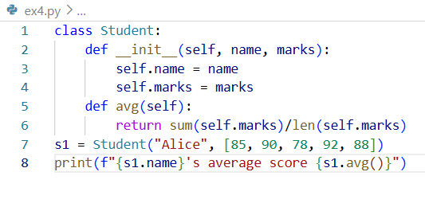

Exercise 5: Product Class with Stock Value Calculator
Problem Statement: Write a Python program to create a Product class with three instance attributes: name, price, and quantity. Add a method total_value() that returns the total stock value by multiplying price by quantity.
Purpose: This exercise models a real-world business scenario using OOP. It reinforces how instance methods can derive new information from existing attributes, a pattern widely used in inventory management, e-commerce, and financial applications.
Given Input: p1 = Product("Laptop", 899.99, 5)
Expected Output: Total stock value of Laptop: $4499.95
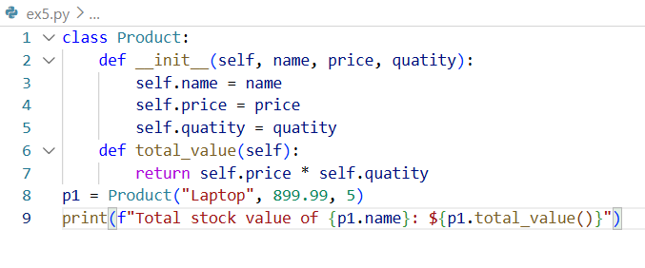
Exercise 6: Bank Account with Deposit & Overdraw Protection
Problem Statement: Write a Python program to create a BankAccount class with a balance attribute and two methods: deposit(amount) that adds funds to the balance, and withdraw(amount) that deducts funds but prevents the balance from going below zero.
Purpose: Learn data validation and conditional logic inside instance methods. Preventing overdraw is a real-world business rule, and implementing it here teaches you how classes can enforce constraints on their own data, a core idea behind encapsulation in OOP.
Given Input: Starting balance of 1000, deposit 500, withdraw 200, then attempt to withdraw 2000.
Expected output:
Balance after deposit: 1500
Balance after withdrawal: 1300
Insufficient funds. Current balance: 1300
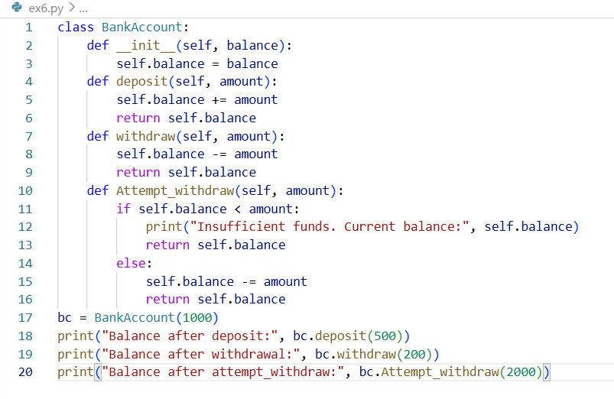
Exercise 7: Light Class with On/Off State Toggle
Problem Statement: Write a Python program to create a Light class with three methods: turn_on() that switches the light on, turn_off() that switches it off, and status() that reports whether the light is currently on or off.
Purpose: This exercise models a simple stateful object, where the object remembers and changes its own condition over time. It introduces the concept of state management within a class, a pattern found everywhere from UI components and IoT devices to game objects and workflow engines.
Given Input: Create a Light object, call turn_on(), check status(), call turn_off(), and check status() again.
Expected Output:
Light is ON
Current status: ON
Light is OFF
Current status: OFF
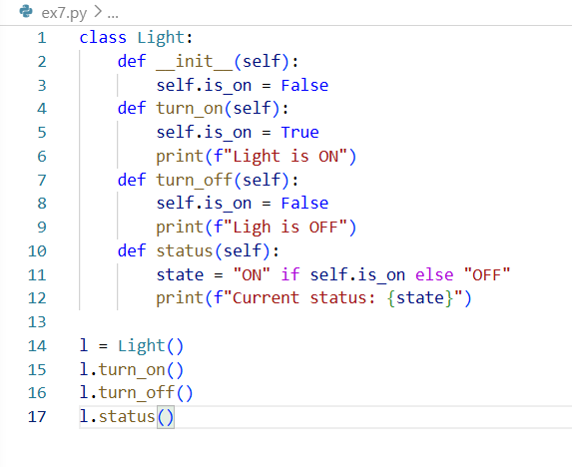
Exercise 8: User Class with Password Validation
Problem Statement: Write a Python program to create a User class that stores a username and a password. Add a check_password(input_password) method that returns True if the input matches the stored password, and False otherwise.
Purpose: This exercise introduces the idea of controlled access to sensitive data inside a class. Rather than exposing the password directly, the class provides a dedicated method to verify it. This pattern reflects a core principle of encapsulation in OOP, where internal data is protected and accessed only through defined interfaces.
Given Input: u1 = User("alice", "secure123")
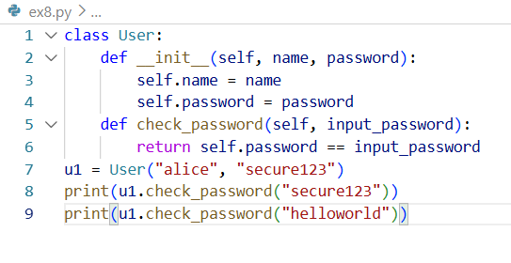
Exercise 9: Temperature Class with Unit Converters
Problem Statement: Write a Python program to create a Temperature class that stores a temperature in Celsius. Add two methods: to_fahrenheit() that converts and returns the value in Fahrenheit, and to_kelvin() that converts and returns the value in Kelvin.
Purpose: This exercise demonstrates how a class can act as a data container with built-in conversion logic. It reinforces writing multiple methods that all operate on the same instance attribute, and applies straightforward mathematical formulas in a practical scientific context.
Given Input: t = Temperature(100)
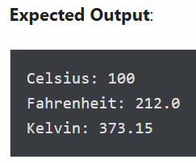
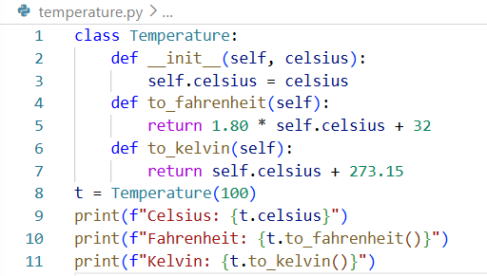
Exercise 10: Notebook Class with Add & Display Notes
Problem Statement: Write a Python program to create a Notebook class that maintains an internal list of notes. Add an add_note(note) method that appends a new note to the list, and a show_notes() method that prints all stored notes.
Purpose: This exercise shows how a class can manage a growing collection of data over its lifetime. It practices initializing a mutable data structure inside __init__ and writing methods that both modify and read that structure, a pattern that appears in todo lists, message queues, logs, and many other applications.
Given Input: Add three notes: "Buy groceries", "Read a book", "Call the doctor".
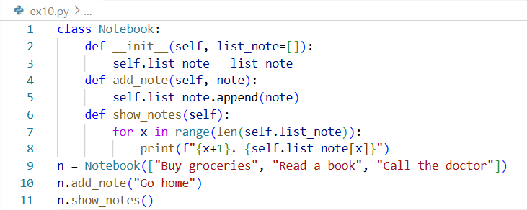
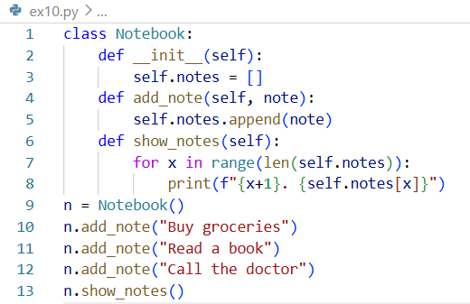

Another solution

Exercise 11: Coffee Machine with Multi-Resource Tracking
Problem Statement: Write a Python program to create a CoffeeMachine class that tracks three resource attributes: water, coffee, and milk (in ml/g). Add a make_latte() method that checks whether sufficient resources are available, deducts them if so, and prints an appropriate message in either case.
Purpose: This exercise combines state management, resource tracking, and conditional logic inside a single class. It mirrors how real-world stateful systems (vending machines, inventory systems, game resource managers) check preconditions before executing an action and update their internal state only when the action is valid.
Given Input: CoffeeMachine(water=300, coffee=100, milk=200). A latte requires 200ml water, 20g coffee, and 150ml milk.

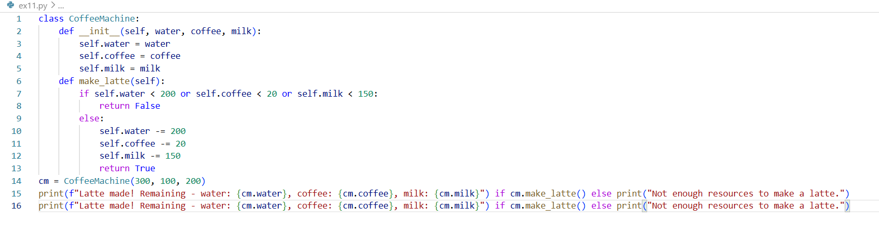
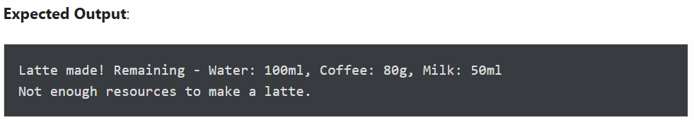

Exercise 12: Shared Class Attribute Across Instances
Problem Statement: Write a Python program to create a Vehicle class with a class attribute color = "White" that is shared by all instances. Create two vehicle objects and demonstrate that both share the same default color, then show that changing the class attribute updates all instances that have not overridden it.
Purpose: This exercise clarifies the distinction between class attributes and instance attributes. Class attributes are defined directly on the class and shared across everyinstance, making them ideal for default values or constants that apply universally. Understanding this difference prevents subtle bugs when mutable data is accidentally shared between objects.
Given Input: v1 = Vehicle("Tesla", 250) and v2 = Vehicle("BMW", 200).
Expected Output:
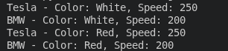
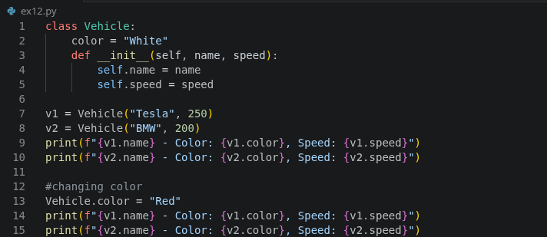

Exercise 13: Bus Subclass Inheriting from Vehicle
Problem Statement: Write a Python program to create a Vehicle parent class with name and max_speed attributes and a display() method. Then create a Bus child class that inherits everything from Vehicle without adding anything new, and confirm that an instance of Bus can access the parent’s method.
Purpose: This exercise introduces inheritance, one of the four pillars of OOP. Inheritance lets a child class automatically receive all attributes and methiods from its parent, promoting code reuse and expressing natural “is-a” relationships. A Bus is a Vehicle, so it makes sense for it to share the same interface.
Given Input: bus1 = Bus("School Bus", 120)
Expected Output: Vehicle: School Bus, Max Speed: 120 km/h
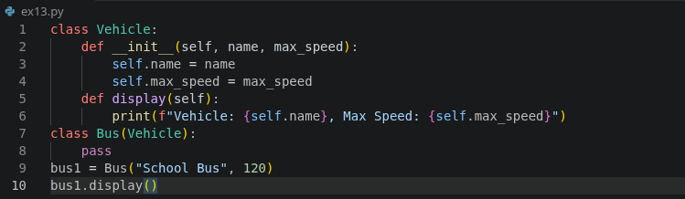

Exercise 14: verride Parent Method Using super()
Problem Statement: Write a Python program where a Vehicle parent class has a seating_capacity() method that accepts a capacity argument. Create a Bus child class that overrides this method to provide a default seating capacity of 50, using super() to call the parent’s version internally.
Purpose: This exercise covers method overriding and the use of super(), two key tools in OOP inheritance. Overriding lets a child class customize or extend a parent method’s behavior without rewriting it from scratch. super() delegates part of the work back to the parent, keeping the code DRY and maintaining the original logic as a foundation.
Given Input: bus = Bus("School Bus", 120)
Expected Output: School Bus seating capacity is: 50
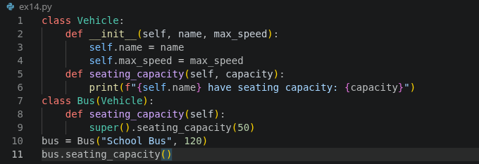

Exercise 15: Add Maintenance Fee in Child Class via super()
Problem Statement: Write a Python program that creates a Vehicle parent class with a base fare, then extends a Taxi child class that adds a 10% maintenance fee on top of the base fare using super().
Purpose: This exercise teaches you how to use super() to call the parent class constructor, extend child class behaviour by building on inherited attributes, and model real-world pricing logic using inheritance.Given Input: base_fare = 500
Expected Output: Total fare with maintenance fee: 550.0
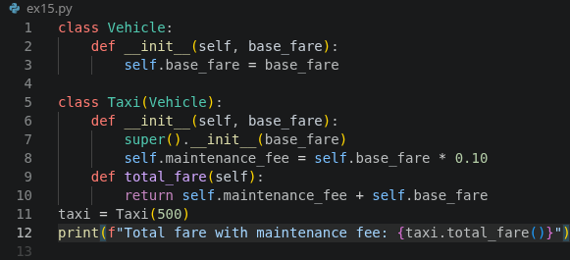

Exercise 16: Polymorphism with Dog & Cat speak()
Problem Statement: Write a Python program that defines an Animal base class with a speak() method, then overrides it in Dog and Cat subclasses to return their respective sounds.
Purpose: This exercise introduces method overriding, one of the core pillars of polymorphism in OOP. It shows how different subclasses can share the same interface but provide their own specific behaviour.
Given Input: Objects of Dog and Cat classes
Expected Output:
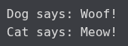
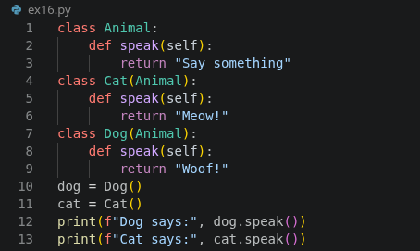

Exercise 17: Full-Time vs Part-Time Employee Pay Logic
Problem Statement: Write a Python program that defines an Employee base class, then creates FullTimeEmployee and PartTimeEmployee subclasses, each implementing different pay calculation logic.
Purpose: This exercise models a common HR scenario and teaches you how to use inheritance to share common attributes while allowing each subclass to define its own business logic for calculating pay.
Given Input: FullTimeEmployee("Alice", 60000) and PartTimeEmployee("Bob", 500, 20)
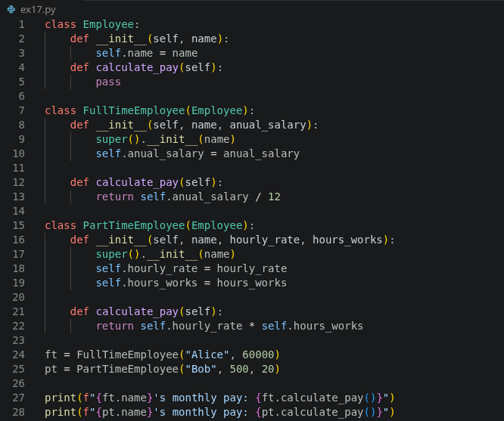

Exercise 18: Shape Subclasses with Custom area() Methods
Problem Statement: Write a Python program that defines a Shape base class with an area() method, then implements it in Circle, Square, and Triangle subclasses using the appropriate geometric formulas.
Purpose: This exercise is a classic demonstration of polymorphism. Each shape shares the same area() interface but provides a completely different calculation, showing how OOP handles real-world variation cleanly.
Given Input: Circle(7), Square(4), Triangle(6, 8)
Expected Output:
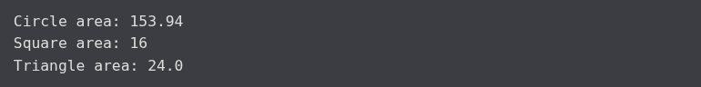
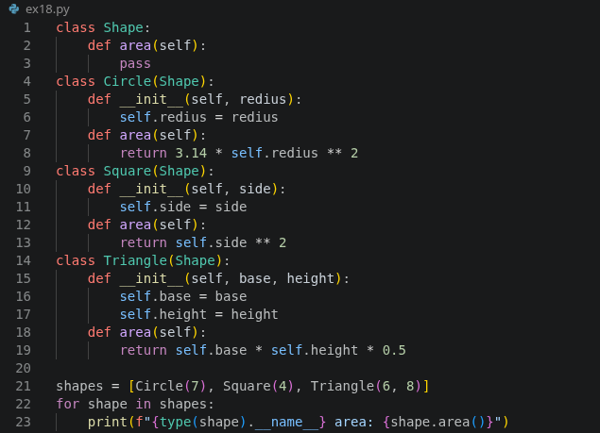

Exercise 19: Media Subclasses with Type-Specific Attributes
Problem Statement: Write a Python program that defines a Media base class, then creates Book, Magazine, and DVD subclasses, each with type-specific attributes and a describe() method.
Purpose: This exercise shows how inheritance can model a taxonomy of related objects. Each media type shares a common identity (title, price) but carries unique attributes specific to its format, reflecting real-world library or inventory systems.
Given Input: Book("Clean Code", 499, "Robert C. Martin"), Magazine("Wired", 150, "Monthly"), DVD("Inception", 299, 148)
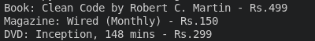
Expected Output:

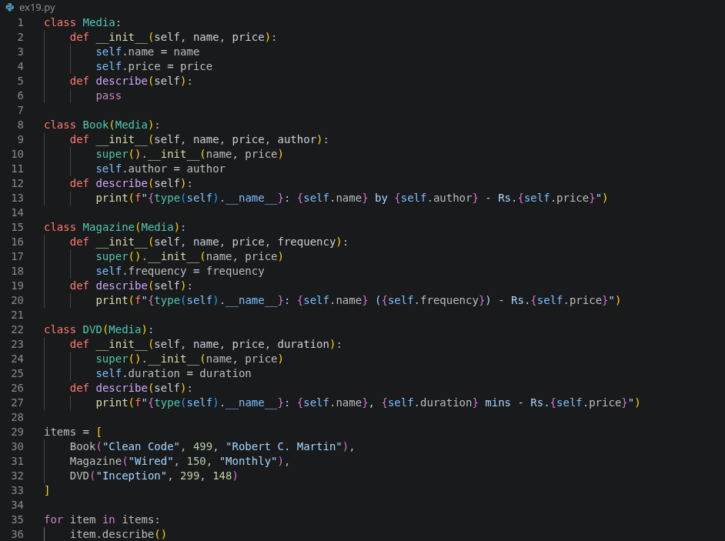

Exercise 20: Discounted Order Subclass with 10% Off
Problem Statement: Write a Python program that creates an Order class with a total amount, then creates a DiscountedOrder subclass that applies a 10% discount to the total.
Purpose: This exercise models a common e-commerce pattern and shows how a child class can extend a parent’s behaviour by modifying a calculated value, without changing the parent class at all.
Given Input: DiscountedOrder("ORD001", 1200)
Expected Output:
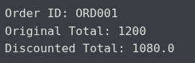

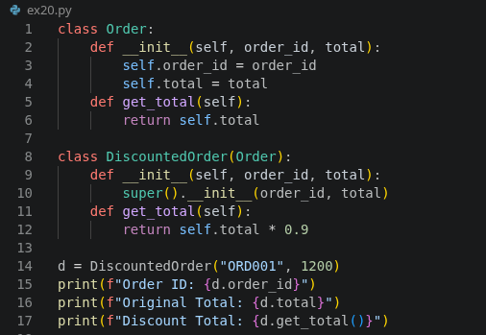

s

